**Digita no. empleado, y al dar search carga informacion**

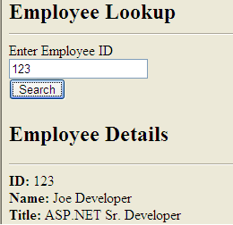

**Se puede hacer de 2 formas**

* **Llamar a un web service**
* **Llamar a un web method en code behind**

**EN ESTE CASO SE CREARA UNA WEB SERVICE DE TIPO ASMX**

1. Creen un Nuevo web site en C# y agregue un web servicea website llamado **EmployeeService.asmx**.

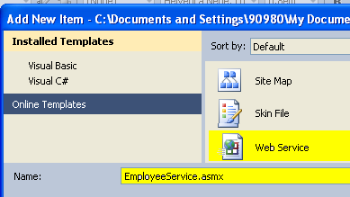

Se agrego una clase en App_Code modifique el archivo EmployeeService.cs para que sea como el siguiente:

using System;

using System.Collections.Generic;

using System.Linq;

using System.Web;

using System.Web.Services;

SE DECLARA UNA CLASE QUE SE CARGARA QUE DEBE SER SERIALIZABLE

**[Serializable]**

**public class Employee**

{

public Employee(string empId)

{

//simulate looking up an employee

this.ID = empId;

this.FullName = "Joe Developer";

this.Title = "ASP.NET Sr. Developer";

}

public Employee()

{

}

public string FullName { get; set; }

public string ID { get; set; }

public string Title { get; set; }

}

[WebService(Namespace = "**http://localhost:6752/WebSite10/")]**

[WebServiceBinding(ConformsTo = WsiProfiles.BasicProfile1_1)]

[System.Web.Script.Services.ScriptService]

public class EmployeeService : System.Web.Services.WebService

{

[WebMethod]

public Employee GetEmployeeById(string employeeId)

{

//simulate employee name lookup

return new Employee(employeeId);

}

}

Todo lo anterior es parte del web service

**IMPORTANTE: Verifique** [**http://localhost:6752/WebSite10/**](http://localhost:6752/WebSite10/) al correr cada brwoser

2) EL SEGUNDO PASO, LLAMAR A LA WEB SERVICE DESDE EL AJAX

<head runat="server">

<title></title>

<script src="**Scripts/jquery-1.4.1.js**" type="text/javascript"></script>

</head>

<body>

<script type="text/javascript">

$(document).ready(function() {

$("#**ButtonSearch**").click(function() {

$("#**empDetails**").hide("slow");

var empId = $("#**TextBoxEmpId**").val();

$.ajax({

type: "POST",

dataType: "json",

contentType: "application/json",

url: "**EmployeeService.asmx/GetEmployeeById**",

data: "{'employeeId': '" + empId.toString() + "'}",

success: function(data) {

$("#textId").html(data.d.ID);

$("#textName").html(data.d.FullName);

$("#textTitle").html(data.d.Title);

/// show employee details

$("#**empDetails**").show("slow");

},

error: function() { alert("Error calling web service."); }

});

});

});

</script>

<form id="form1" runat="server">

<h2>Employee Lookup</h2>

<hr />

Enter Employee ID

<br />

<asp:TextBox ID="**TextBoxEmpId**" runat="server"></asp:TextBox>&nbsp;

<br />

<input type="button" id="**ButtonSearch**" runat="server" value="Search" />

<div id="**empDetails**" style="display: none; margin-top: 40px">

<h2>Employee Details</h2>

<hr />

<b>ID: </b>&nbsp;<span id="textId"> </span><br />

<b>Name:</b>&nbsp;<span id="textName"></span><br />

<b>Title:</b>&nbsp;<span id="textTitle"></span><br />

</div>

</form>

</body>

</html>

**En el projecto debe crear el folder script y agregar el archivo que les envio jquery-1.4.1.js**



Si se utiliza master pages entonces el script es

<asp:Content ID="**Content2**" ContentPlaceHolderID="**ContentPlaceHolder1**" Runat="Server">

<script type="text/javascript">

$(document).ready(function () {

$("#**ctl00_ContentPlaceHolder1**_ButtonSearch").click(function () {

/// alert (“Button Click”);

/// hide employee details (if shown)

$("#**empDetails**").hide("slow");

var empId = $("#**ctl00_ContentPlaceHolder1**_**TextBoxEmpId**").val();

$.ajax({

type: "POST",

dataType: "json",

contentType: "application/json",

url: "EmployeeService.asmx/GetEmployeeById",

data: "{'employeeId': '" + empId.toString() + "'}",

success: function (data) {

$("#textId").html(data.d.ID);

$("#textName").html(data.d.FullName);

$("#textTitle").html(data.d.Title);

$("#textDepartment").html(data.d.Department);

/// show employee details

$("#**empDetails**").show("slow");

},

error: function () { alert("Error calling the web service."); }

});

});

});

</script>